Effects of the 2021 EITC Expansion on Household Food Sufficiency

Peter Amerkhanian, 12/11/2022

# Executive Summary

The Advance Child Tax Credit (CTC) was a temporary expansion of the CTC that dispersed monthly checks ranging from $250 to $300 dollars per child to eligible households. This report finds that the Advance CTC reduced the prevalence of household food insecurity for recipients.

# Background

In the U.S. tax code, there are two provisions explicitly designed to redistribute money towards low-income tax filers: The Earned Income Tax Credit (EITC) and the Child Tax Credit (CTC).[1] Since its introduction in 1975, the EITC has become the central element of the U.S.’ social safety net.[2] The CTC is structurally similar to the EITC, but it is targeted towards most families with children rather than just low-income families, and its maximum benefit is much smaller.[3]

In 2021, the CTC was expanded after passage of the American Rescue Plan (ARP). ARP expanded CTC eligibility to almost all families with children in tax-year 2021, with any family earning below $150,000 receiving the full credit.[4] ARP also expanded CTC eligibility to families without income and increased the maximum credit value to $3,000 per-child aged 6-17 and $3,600 per-child under 6. One of the key changes for the purposes of this study is that under ARP, half of the CTC was delivered in monthly installments (up to $250 per-child aged 6-17, $300 per-child under 6) between July and December 2021.

Previous research has found that the EITC and CTC generally have a variety of positive effects on family well-being as measured by maternal and child health, food sufficiency, parent mental health, and child educational attainment.[5] Thus far, at least one impact evaluation specific to the Advance CTC by (Parolin et. al. 2021) found that the payments decreased food insecurity.

# Data and Research Question

My principal questions are: How did the Advance CTC affect household food insecurity generally, did it cause households to depend less on foodbanks, and did it reduce household enrollment in the Supplemental Nutritional Assistance Program (SNAP)?

To answer these, I utilize the Household Pulse Survey (Pulse), an experimental survey conducted during the pandemic by the United States Census Bureau. It is a nationally representative random survey, though it suffers from non-response bias.[6] I use the Census’ household weights for all calculations.

# Trends in Treatment

The Advance CTC was disbursed to most families with children. Table 2 shows that, in percentage terms, fewer low-income households received the Advance CTC than did higher income households. However, lower income households also typically have more children, thus increasing their average benefit size. Having children under 6 increases benefit size from $250 to $300, but I find that the proportion of families with children under 5 (the Pulse does not track whether a family has children under 6) does not vary considerably by income group.

|  |  |  |  |  |
| --- | --- | --- | --- | --- |
| **Income Group** | **Families with Children Received CTC** | **Average Estimated Monthly Benefit** | **Average # Kids** | **Families with Kids Under 5** |
| **<$25k** | 0.55 | 521.21 | 2.01 | 0.36 |
| **$25k - $35k** | 0.64 | 527.32 | 2.04 | 0.35 |
| **$35k - $50k** | 0.65 | 531.64 | 2.05 | 0.39 |
| **$50k - $75k** | 0.67 | 509.06 | 1.96 | 0.37 |
| **$75k - $100k** | 0.68 | 504.53 | 1.94 | 0.41 |
| **$100k - $150k** | 0.69 | 497.01 | 1.91 | 0.38 |
| **$150k - $200k** | 0.63 | 478.16 | 1.84 | 0.36 |
| **>$200k** | 0.49 | 507.45 | 1.95 | 0.38 |

Table

Use of the Advance CTC payments varied by household, though most paid off debt or else spent the money rather than saving it. Figure 1 shows that the most popular spending category was food, followed by utilities payments, clothing, and school supplies.

Figure

# Empirical Strategy

To find the causal effect of the Advance CTC on food sufficiency, I estimate several difference-in-difference models as defined in equation (1):

$y_{i}=α_{i}+{ β}_{1}Eligible_{i}+β_{2}Week_{t}+β_{3}Eligible_{i}×1\left(Week_{t}∈\left[34,…, 39\right]\right)+ϵ_{i}$ (1)

Where $β_{3}$ is the effect of the monthly CTC payments and $y_{i}$ is a binary indicator of the food sufficiency-related outcome. The treatment is defined as the interaction between eligibility for the expanded CTC and observation between weeks 34 and 39 of the Pulse survey, which roughly corresponds to the start of July and December 2021 respectively. The raw data, shown in Figure 2, exhibits sharp post-treatment discontinuities in the incidence of food insecurity, receiving free food, and SNAP enrollment, suggesting possible effects.

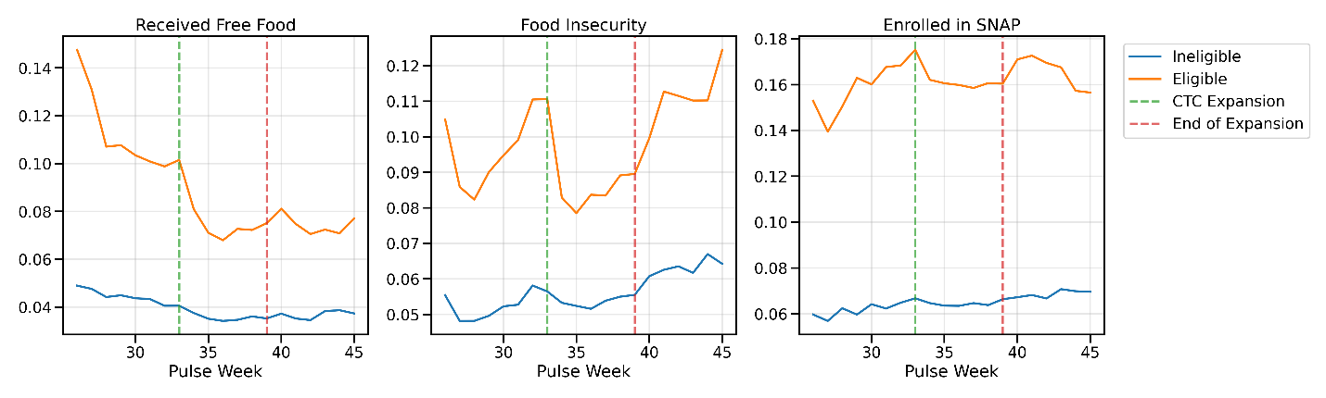

Figure

# Effects of the Advance CTC

I estimate the Advance CTC’s effects on whether a household received free food in the last seven days, whether they describe themselves as experiencing food insecurity, and whether they are enrolled in SNAP. I compute estimates with the control group defined as those with no children and the treatment group defined in the following five ways: those who are eligible for the Advance CTC and have any children, those eligible with specifically one child, two, three, and four children. By including the effects of specific child counts I get a general sense of how increases to the Advance CTC monthly check amount affects the outcome of interest. All estimates are shown in Table 3.

|  |  |  |  |  |  |
| --- | --- | --- | --- | --- | --- |
|  | Children Generally | One Child | Two Children | Three Children | Four Children |
| Received Free Food | -0.0181*** | -0.0141*** | -0.0168*** | -0.0218** | -0.0485*** |
| (0.0033) | (0.0042) | (0.0053) | (0.0095) | (0.0169) |
| **Food Insecurity** | **-0.0256\*\*\*** | -0.0206*** | -0.0264*** | -0.0375*** | -0.0395** |
| (0.0037) | (0.0049) | (0.0058) | (0.0090) | (0.0180) |
| Enrolled in SNAP | 0.0102** | 0.0126** | 0.0047 | 0.0196 | 0.0080 |
| (0.0046) | (0.0058) | (0.0073) | (0.0134) | (0.0222) |
| N | 842783 | 713637 | 679113 | 628867 | 608418 |
| Fixed Effects | Week/Group | Week/Group | Week/Group | Week/Group | Week/Group |
| Note: $* p<.05, **p<.01, ***p<.001$, **Bold** denotes parallel trends satisfied for households with children generally. Robust standard errors reported in parenthesis. | | | | | |

Table

To probe parallel trends assumptions that are necessary for this research design, I also estimate an event study model. Full results are available in the appendix, but the principal findings are that parallel trends were satisfied only for Food Insecurity, seen in Figure 3.

# Discussion

The estimated negative effects on food insecurity are consistent with the descriptive analysis presented in Figure 1, which showed that the top spending category for the Advance CTC was food. Food insecurity also quickly rises again after treatment ends, strengthening the claim that receiving or not receiving the Advance CTC has bearing on food insecurity. Though parallel trends did not hold, I found that households reported receiving free food (e.g., from a food pantry, food bank, church) less post-treatment, a reduction that may have been related to Advance CTC payments. There are essentially no effects on SNAP enrollment. I find that the effects on food insecurity seem to increase for households with more children, who receive either $250 or $300 more each month for each child: -0.02 for households with one child, -0.026 for two, -0.038 for three, and -0.04 for four. This would suggest that the more money dispersed, the more the incidence of food insecurity fell.

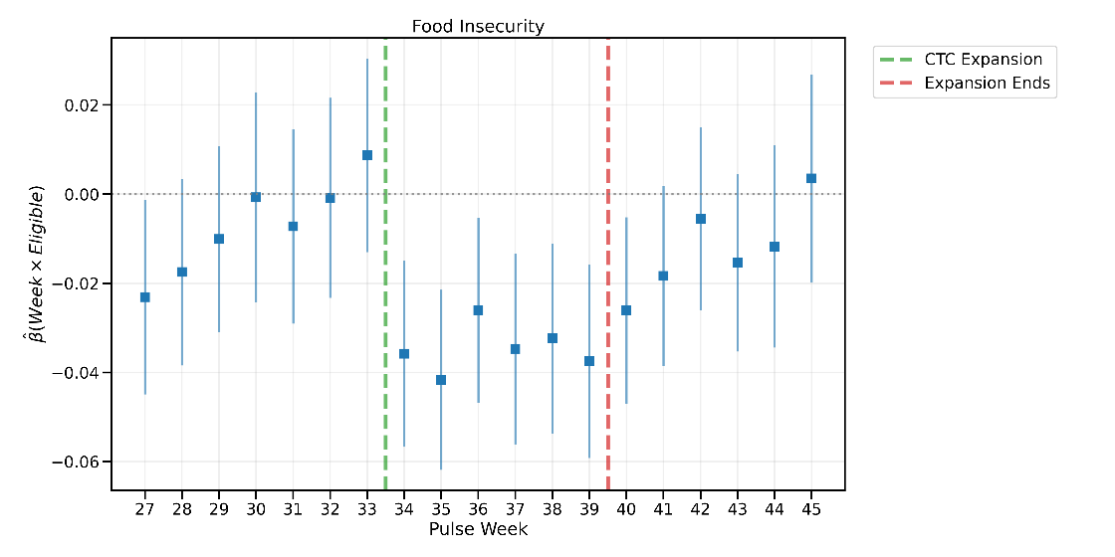

Figure

# Opportunities for Further Research

There is still much to explore regarding the Advance CTC payments’ effects on household well-being, even using this same data. For one, there is the opportunity to delve more into the effect of receiving $300 from having a child under 6 years old versus $250 for a child between 6 and 17. However, given that the Pulse only observed whether a household has children under 5 *after* the rollout of the Advance CTC, this could only be examined through an observational, rather than quasi experimental study.

# Appendix:

## Eligibility for the CTC

Eligibility is defined according to the eligibility requirements for receiving the expanded CTC – families with at least one child under 18 and annual income less than $150,000 for married couples and $112,500 for single households. The Pulse only observed income groups broken up into $25,000 bins, so I use $100,000 as a stand-in for the single household cutoff. I compare this eligibility definition with the data on Advance CTC receipt observed between July and December, presented in Table 3, where True Positive denotes that they are both declared eligible and go on to receive the Advance CTC.

|  |  |  |
| --- | --- | --- |
| **Eligibility Definition** | **True Positive** | **False Positive** |
| **Has Kids** | 0.6335 | 0.3665 |
| **Has Kids & Inc<150k** | 0.6612 | 0.3388 |
| **Has Kids & Inc<150k & Married** | 0.7011 | 0.2989 |
| **Has Kids & [(Inc<150k & Married) Or (Inc<100k & not Married)]** | 0.6661 | 0.3339 |

Table 3

I decide to use the third definition: a household is eligible for the Advance CTC payments if they have kids, and either earn less than $150,000 and are married, or else earn less than $100,000 and are single. Although this definition’s True Positive rate is lower than the second, it is closest to the formal definition of eligibility for the full Advance CTC payment.[7]

## Dependent Variable Definitions

“Received Free Food” is defined as someone in a household getting free groceries from a food pantry, food bank, church, or other place that provides free food in the last seven days. “Food Insecurity” is defined as sometimes or often not having enough to eat in the last seven days. “Enrolled in SNAP” is defined as someone in the household being currently enrolled in SNAP benefits.[8]

## Event Study Estimates

Given the event study specification:

$y_{i}=α_{i}+{ β}_{1}Eligible_{i}+β_{2}Week_{t}+β_{3}Eligible_{i}×Week_{t}+ϵ_{i}$

The table below shows the estimate of $β_{3}$ for various outcomes $y$.

|  |  |  |  |  |
| --- | --- | --- | --- | --- |
| **Coefficient** | **Received Free Food** | **Food Insecurity** | **Enrolled in SNAP** | **Treatment** |
| C(Week)[T.27]:Eligible | -0.0204** | -0.0231** | -0.0165 | No |
| C(Week)[T.28]:Eligible | -0.0113 | -0.0175 | -0.0122 | No |
| C(Week)[T.29]:Eligible | -0.0194** | -0.0101 | 0.0181 | No |
| C(Week)[T.30]:Eligible | -0.0076 | -0.0007 | 0.0077 | No |
| C(Week)[T.31]:Eligible | -0.0268*** | -0.0072 | 0.0172 | No |
| C(Week)[T.32]:Eligible | -0.0289*** | -0.0008 | 0.0032 | No |
| C(Week)[T.33]:Eligible | -0.0169* | 0.0087 | 0.0110 | No |
| C(Week)[T.34]:Eligible | -0.0425*** | -0.0358*** | 0.0299** | Treatment |
| C(Week)[T.35]:Eligible | -0.0582*** | -0.0416*** | 0.0040 | Treatment |
| C(Week)[T.36]:Eligible | -0.0522*** | -0.0261** | 0.0069 | Treatment |
| C(Week)[T.37]:Eligible | -0.0536*** | -0.0347*** | 0.0148 | Treatment |
| C(Week)[T.38]:Eligible | -0.0539*** | -0.0324*** | 0.0032 | Treatment |
| C(Week)[T.39]:Eligible | -0.0382*** | -0.0375*** | 0.0117 | Treatment |
| C(Week)[T.40]:Eligible | -0.0382*** | -0.0261** | 0.0137 | No |
| C(Week)[T.41]:Eligible | -0.0508*** | -0.0184* | 0.0068 | No |
| C(Week)[T.42]:Eligible | -0.0496*** | -0.0055 | 0.0047 | No |
| C(Week)[T.43]:Eligible | -0.0606*** | -0.0153 | -0.0094 | No |
| C(Week)[T.44]:Eligible | -0.0563*** | -0.0117 | -0.0104 | No |
| C(Week)[T.45]:Eligible | -0.0460*** | 0.0035 | -0.0122 | No |

Note: $*p<.05, **p<.01, ***p<.001$

# Bibliography

Bitler, Marianne, Hilary Hoynes, and Elira Kuka. “Child Poverty, the Great Recession, and the Social Safety Net in the United States.” Working Paper. Working Paper Series. National Bureau of Economic Research, September 2016. https://doi.org/10.3386/w22682.

Bureau, US Census. “Household Pulse Survey Technical Documentation.” Census.gov. Accessed November 11, 2022. https://www.census.gov/programs-surveys/household-pulse-survey/technical-documentation.html.

Hoynes, Hilary, and Jesse Rothstein. “Tax Policy Toward Low-Income Families.” Working Paper. Working Paper Series. National Bureau of Economic Research, March 2016. https://doi.org/10.3386/w22080.

Center on Budget and Policy Priorities. “Income Support Associated With Improved Health Outcomes for Children, Many Studies Show.” Accessed December 9, 2022. https://www.cbpp.org/research/federal-tax/income-support-associated-with-improved-health-outcomes-for-children-many.

Parolin, Zachary, Elizabeth Ananat, Sophie M. Collyer, Megan Curran, and Christopher Wimer. “The Initial Effects of the Expanded Child Tax Credit on Material Hardship.” Working Paper. Working Paper Series. National Bureau of Economic Research, September 2021. https://doi.org/10.3386/w29285.

“Phase 3.2 Household Pulse Survey,” n.d., 37.

“The 2021 Child Tax Credit | Information About Payments & Eligibility.” Accessed December 9, 2022. https://www.childtaxcredit.gov/.

1. Hoynes and Rothstein, “Tax Policy Toward Low-Income Families.”
2. Bitler, Hoynes, and Kuka, “Child Poverty, the Great Recession, and the Social Safety Net in the United States.”
3. Hoynes and Rothstein, “Tax Policy Toward Low-Income Families.”
4. Parolin et al., “The Initial Effects of the Expanded Child Tax Credit on Material Hardship.”
5. “Income Support Associated With Improved Health Outcomes for Children, Many Studies Show.”
6. Bureau, “Household Pulse Survey Technical Documentation.”
7. “The 2021 Child Tax Credit | Information About Payments & Eligibility.”
8. “Phase 3.2 Household Pulse Survey.”